**Node-RED Dashboard** is a module that provides a set of nodes in Node-RED to quickly create a live data dashboard.

To install the Node-RED Dashboard:

**node-red-stop**

**cd ~/.node-red**

**npm install node-red-dashboard**

**sudo reboot**

**node-red-start**

To open the Node-RED UI

<http://Your_RPi_IP_address:1880/ui>

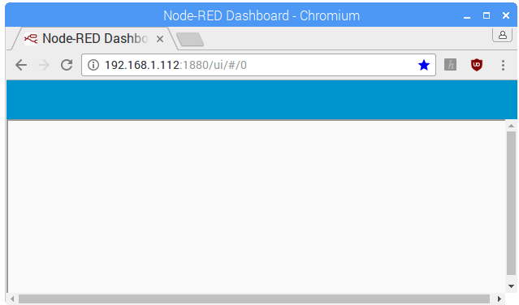

Open another tab in your browser to access Node-RED with:

Inicie con:

http://Your_RPi_IP_address**:1880**

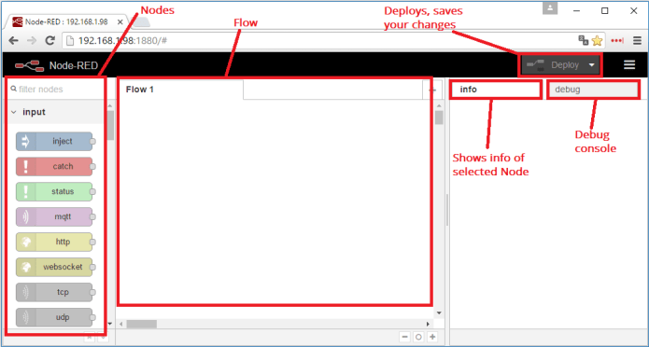

Como ya instalo dashboard desde menu / Manage Palette / Install / (search dashboard) le aparecera los siguientes nodos:

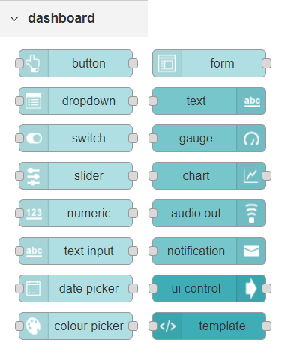

Debe crear los tabs y grupos

Sino aparece Dashboard hay una fecha donde aparece en un drop

* Informacion
* Help
* Debug
* Configurar
* Context data
* Dashboard

Escoja Dashboard

|  |  |
| --- | --- |
|  | * On top right corner of the Node-RED window you have a tab called **dashboard**. * Select that tab **(1)**. To add a tab to the user interface click on the **+tab** button **(2)**. * Once created, you can edit the tab by clicking on the **edit** button **(3)**. |

You can edit the tab’s name and change its icon:

* **Name**: you can call it whatever you want
* **icon**:  you should use a name accordingly to the icon’s names in this link: [https://klarsys.github.io/angular-material-icons](https://klarsys.github.io/angular-material-icons/)

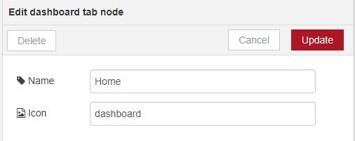

After creating a tab, you can create several groups under that tab. You need to create at least one group to add your widgets. To add a group to the created tab, you need to click on the **+group** button **(4)**.

Then, you can edit the created group by clicking on the **edit** button **(5)**.

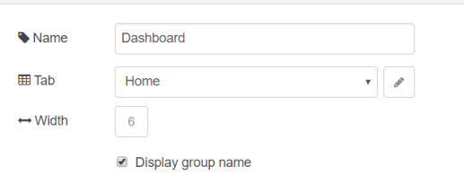

You can edit its name, select its corresponding tab and change its width.

You can edit its colors in the **Theme**tab on the up right corner as show:

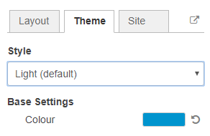

### Dashboard Site

At the right upper corner of the Node-RED window, you have another tab called **Site** that allows you to do further customization as show in the figure below.

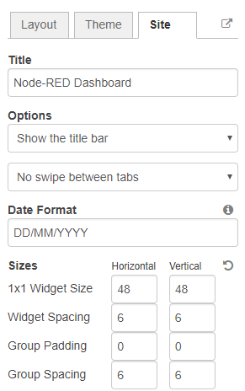

## Creating a User Interface

This dashboard will have the following features:

* Two different tabs: one called **Room** and another called **Garden**
* The Room tab will have two groups and the Garden tab will have one group
* We’ll add a color picker and a switch to the room groups
* We’ll add a chart to the Garden group

### Creating the Tabs

On the top right corner on the Node-RED window, select the **dashboard** tab and create two new tabs by clicking on the **+tab** button.

|  |  |  |
| --- | --- | --- |
| Tab Room | Tab Garden |  |
| * **Name**: Room * **Icon**: tv | * **Name:**Garden * **Icon:**local_florist |  |

Then, add two groups to the Room tab and one group to the Garden tab. The following figure shows how your dashboard layout looks.

### Adding the Widgets

Add a switch, a slider, a colour picker and a gauge to the flow as show in the following figure:

**EN FLOW SE PONE TODOS LOS NODES, SE CONECTAN, Y LUEGO SE ASIGNAN QUE NODES SE PONEN EN CADA TAB / GRUPO**

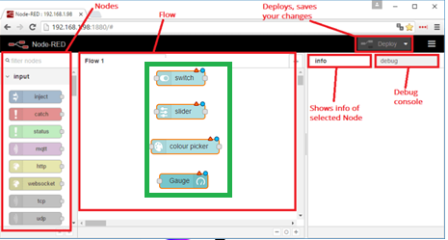

Double click on the switch. A new window pops up.

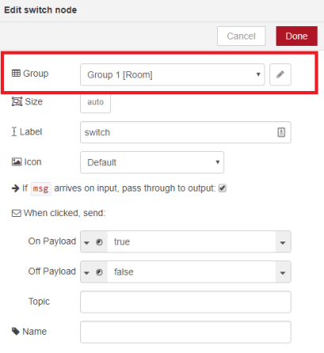

In this new window you can choose where you want your button widget to appear.

In this case we want it to appear in the Room tab, Group 1 as highlighted in red in the previous figure.

Then, do the same for the other widgets but add them to the following groups:

|  |  |
| --- | --- |
| Your dashboard has two tabs: **Room and Garden** as highlighted in the following figure: |  |

|  |  |
| --- | --- |
| Room Tab looks with 2 groups  **slider**: Group 1 [Room]  **colour picker**: Group 2 [Room]  /ui/#/1 | Garden tab with one group, Gauge  **gauge:** Group 1 [Garden]  /ui/#/0 |
|  |  |

Deploy the changes and go to the dashboard UI to see how it looks.

<http://Your_RPi_IP_address:1880/ui>